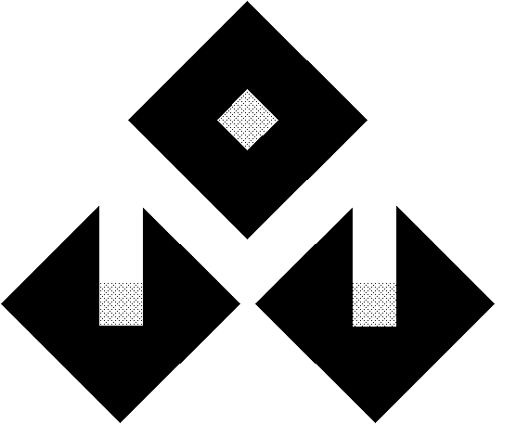
*
(incorporated in Bermuda with limited liability)
(Stock Code : 00526)

SUSPENSION OF TRADING

At the request of Magician Industries (Holdings) Limited (the “Company”), trading in the Company’s shares will be suspended with effect from 9:30 a.m. on 9 October 2007 pending release of an announcement relating to an open offer.

By Order of the Board
Magician Industries (Holdings) Limited

Xu Jin

Chairman

Hong Kong, 9 October 2007

As at the date of this announcement, the Board comprises Mr Xu Jin (Chairman), being executive director, Mr Lau Kin Hon being non-executive director, Mr He Chengying, Mr Chan Man Sum Ivan and Mr Cheung Kiu Cho Vincent being independent non-executive directors.

* for identification purpose only

